**Help:**

**Metric**

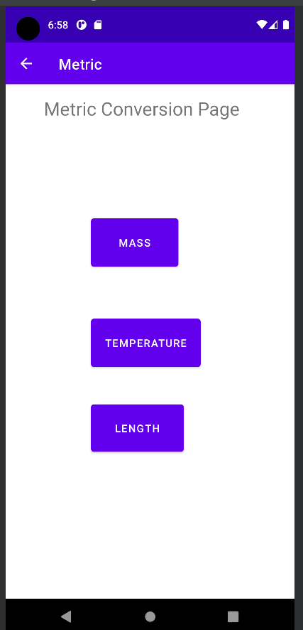

Mass:

Temp:

Length:

**English**

Mass:

Temp:

Length:

